CM4107 CW Part1: Comparative Evaluation

Alistair Quinn
School of Computing Science and Digital Media
RGU
Aberdeen, UK

Abstract—This study compares the accuracies of three machine learning models, ANN, kNN and a hybrid of both for classification problems. Various hyperparameters were altered and tested to find the ideal values for comparing the three models. Two datasets were chosen the first was a wine dataset were the goal is the classify wine samples by a quality value between 0 and 10. The second dataset is a binary classification problem involving classifying potentially cancerous breast tissue samples as benign or malignant. The results showed that for the wine dataset kNN performed best followed closely by the ANN and finally the Hybrid. For the breast cancer dataset however, the Hybrid performed best followed closely by the ANN model and finally the kNN Model. In both cases accuracies for the Hybrid and ANN were very close to each other. Accuracies the ANN and Hybrid wine dataset models were around 50% this indicates an error with either the model or the data itself.

Comparative Study setup
Two datasets have been chosen for the study and they will be used to train and test three models, Ann, kNN and a ANN-kNN Hybrid.
The first dataset chosen was a white wine whine quality dataset. This dataset consists of data from white vinho verde wine samples from the north of Portugal [1]. The classification problem of the dataset is to identify the quality value of a wine sample based on its chemical properties [1]. This dataset was chosen as it has a contains a fair number of categories to classify this should provide a challenge for the models. Not every class is fairly represented this should also add to the difficulty in classifying the dataset. This dataset consists of 12 attributes 1 of them being the class label quality [1]. Quality is a value between 0 and 10 [1]. The dataset contains 4898 instances [1]. The dataset was split in half for the train and test sets using the train_test_split function from the sklearn python library.
The second dataset chosen was a breast cancer dataset. This dataset consists data related to a breast mass. The classification problem of this dataset is to predict if a sample of potentially cancerous breast tissue is malignant of benign [2]. This dataset was chosen so that the study could compare performance between a binary classification problem such as the problem defined for this dataset, and for a more complicated classification problem such as predicting wine quality for the wine dataset. This is to see if different models perform differently for each type of classification problem. This dataset contains 32 attributes including the class label diagnosis [2]. Diagnosis is a string containing M for malignant and B for benign however for the study these strings will be converted to integers, 1 for malignant and 0 for benign [2]. The dataset contains 569 instances [2]. The dataset was split in half for the train and test sets using the train_test_split function from the sklearn python library.
For this study I will test each of the models separately with each data set, I will vary hyperparameters and test accuracy to try and identify the ideal hyperparameter values. I will then test three final models with the ideal hyperparameters and compare the results from the three models.

Neural Network

Neural Network Hyperparameters

Three Hyperparameters of the Neural Network model were investigated. The three hyperparameters were the number of epochs, the batch size and the learning rate. The number of epochs is the number of times the whole training set passes through the neural network [3]. Increasing the number of epochs increases training accuracy of the model however setting the number of epochs too high leads to overfitting meaning the model will not be generalized enough to be accurate with new data it hasn’t seen [3]. The batch size is the number of samples given to the network after which parameter updates happen [3]. For every epoch, every batch of data is fed to the network for training. Learning rate is a measure of how quickly the model updates its weights. Weights are often updated using an optimization method called Gradient Descent during back propagation [4]. A model with a large learning rate will update its weights by a larger value than a model with a lower learning rate. Low learning rates slow learning but will cause the model to converge more smoothly, a large learning rate speeds up learning but the model may never converge as the model will never reach the weight value that reaches the minimum point in a plot of error [4].

Visualisation of Results
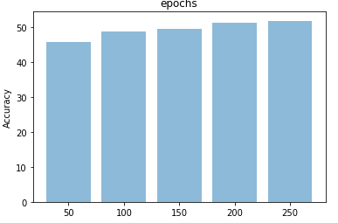
Fig. 1. Wine Dataset Accuracy with varying epoch values
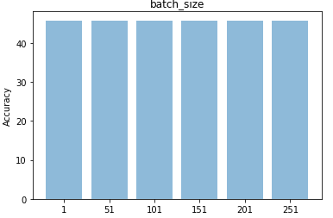
Fig. 2. Wine Dataset Accuracy with varying batch size
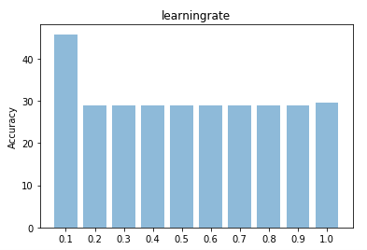
Fig. 3. Wine Dataset Accuracy with varying learning rate

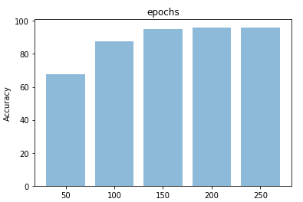
Fig. 4. Breast Cancer Accuracy with varying epochs
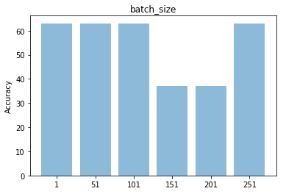
Fig. 5. Breast Cancer Accuracy with varying batch size
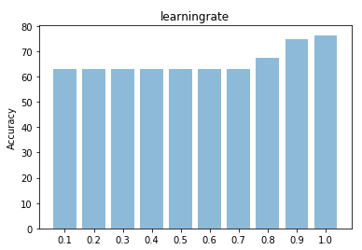
Fig. 6. Breast Cancer Accuracy with varying learning rate

Discussion of Results

As shown in Fig.1 as the number of epochs increased the accuracy of the wine ANN model. Similar trend shown in Fig. 4 for the breast cancer dataset. However, the gain in accuracy between 200 and 250 epochs is marginal. From fig.2 we can see that altering batch size had little to no effect on accuracy for the wine ANN model, perhaps larger batch sizes should have been used. For fig 5. It seems that values of 151 and 201 for batch size causes a large decrease in overall accuracy of the breast cancer ANN however the accuracy increased again at 251. Perhaps a larger set of batch sizes should have been used for this dataset. Fig 3. Shows that a learning rate of 0.1 gave the highest accuracy for the wine dataset and for values >0.1 there was a drastic decrease in accuracy. Values for accuracy between 0.2 and 0.9 are very similar. However as shown in Fig 6. For the breast cancer ANN increasing learning rate had the opposite affect and overall model accuracy increased as the learning rate increased meaning a learning rate of 1.0 produced the highest accuracy. Perhaps if a larger value for epochs had been used a smaller learning rate would have produced better results. Accuracy for the wine ANN model was in the 40-50% range. This is poor and potentially means the model is simply guessing. Perhaps other parameters were incorrectly set. Accuracies for the breast cancer dataset were higher, in the 60-80% range. This is expected as it is a simpler binary classification problem.

k-nearest neighbour

k-NN Hyperparameters
k Nearest Neighbor is an algorithm based on comparing new instances with existing instances. Instances are plotted in multi-dimensional space and when a new instance is queried its ‘k’ nearest neighbors are evaluated to classify the new instance where k is a hyperparameter that defines how many neighbors surrounding the new instance to consider [5]. For example, if k=3 the 3 nearest neighbors to the new instance would be evaluated. kNN works on a voting system to determine the class of the new instance. In unweighted voting, a new instance is classed based on the majority class of k neighbours. In weighted voting the distance or similarity of the neighbours to the new instance is considered [6]. Different similarity functions are used, and these measure distances between the new instance and the nearest neighbors. Examples include Euclidean which measures distances between instances in straight lines and Manhattan with maps distances as vertical and horizontal lines like the street layout of Manhattan [7]. Neighbors which are closer will have a higher influence on the final classification of the new instance. kNN is reffered to as a lazy learner as it doesn’t learn a model instead it stores all instances in memory and computes similarity when queried.

Visualisation of Results
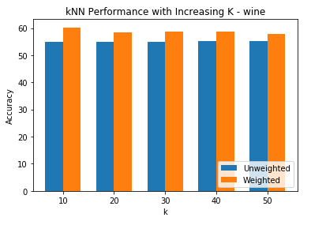
Fig. 7. Wine Accuracy with varying K values

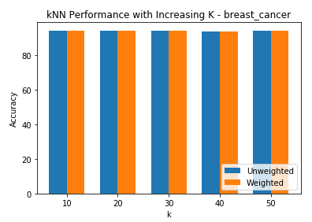
Fig. 8. Breast Cancer Accuracy with varying K values

Discussion of Results
From Fig 7. we can see that as k increased overall accuracy for both the unweighted and weighted kNN models for wine decreased as k increased however weighted model outperformed unweighted models. This is expected as with larger values of K neighboring instances are less likely to be related to the target class. Without weighing to counter this, majority voting will cause decreases in accuracy for unweighted models as the class of each neighbor is treated as being of equal importance to the final classification. K=10 produced the most accurate models. From Fig 8. As k increased overall accuracy of the breast cancer kNN models did not alter by much. Like the wine dataset k=10 produced the most accurate models for breast cancer. Larger ranges of k should have been used for both models this was difficult based to do based on computational constraints. With larger values of K we should have seen better performance with the weighted models as weighted kNN has less meaning with smaller values of k as there is less likely to be a good distribution of different instances with varying class labels.

Hybrid

Combining ANN and k-NN
An ANN-kNN Hybrid was created by adapting an ANN to feed its hidden layer output to a kNN. This was achieved by first training the ANN normally with training data. The modified ANN was then queried with the same training data. The hidden layer output nodes of this query were fed as x inputs into an kNN along with a list of y inputs (target classes). The ANN was modified so that when tested instead of feeding its hidden layer to the final layer it would feed its hidden layer outputs to the kNN created earlier and the results of querying this kNN were returned. By feeding the data to an ANN we get a vectorized representation of the data [8]. The final layer of the ANN returns a probability matrix, so rather than pass this to the kNN we pass the hidden layer output instead as this better represents the data.

Visualisation of Results
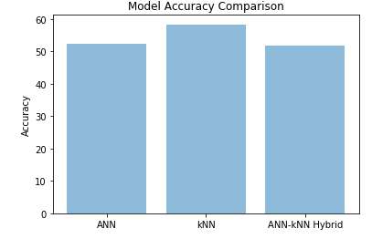
Fig. 9. Wine Accuracy with ANN, kNN and ANN-kNN Hybrid models with ideal hyperparams

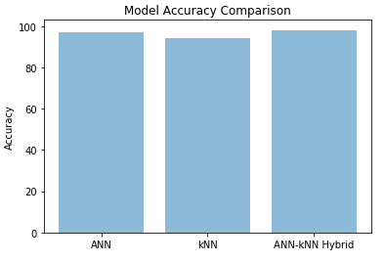
Fig. 10. Breast Cancer Accuracy with ANN, kNN and ANN-kNN Hybrid models with ideal hyperparams

Discussion of Results
As shown in Fig 9. We can see that kNN performed the best, followed by ANN and finally ANN-kNN Hybrid. However the accuracies between the ANN and the Hybrid are very close (within 0.5%). This could mean that parameters set for the ANN were poorly chosen. Accuracies for both ANN and the Hybrid were near 50% this indicates that the models are guessing. This could have been a data preprocessing issue or poorly set parameters. Accuracy for kNN was close to 60%. From fig. 10 we can see that the ANN-kNN Hybrid was the most accurate followed closely by the ANN and final the kNN model. Accuracies were expected to be higher for the hybrid as the hybrid takes the vectorized output of the hidden layer of an ANN and feeds it to a kNN, this improved data representation should create more accurate results. Based on these results it could be proposed that the ANN-kNN hybrid is a better binary classifier than kNN and that kNN is a better classifier when there are more class labels. However, what’s more likely is that parameters for the ANN were set poorly for the wine dataset. More testing would need to be done with different values for hidden layer nodes. The output layer for the wine ANN was set to 11 nodes as the class label of quality for this dataset is supposed to contain values between 0 and 10 however the data does not contain examples of every class label. By altering the amount of output nodes to match only the labels represented accuracies may have been higher.

References

- UCI Machine Learning Repository: Wine Data Set (2018). Available at: https://archive.ics.uci.edu/ml/datasets/wine (Accessed: 25 October 2018).
- Breast Cancer Wisconsin (Diagnostic) Data Set | Kaggle (2016) Kaggle. Available at: https://www.kaggle.com/uciml/breast-cancer-wisconsin-data/home (Accessed: 24 October 2018).
- Radhakrishnan, P. (2017) What are Hyperparameters ? and How to tune the Hyperparameters in a Deep Neural Network?, Towards Data Science. Available at: https://towardsdatascience.com/what-are-hyperparameters-and-how-to-tune-the-hyperparameters-in-a-deep-neural-network-d0604917584a (Accessed: 24 October 2018).
- Jacobs, R. A. (1988) ‘Increased rates of convergence through learning rate adaptation’, Neural Networks. Pergamon, 1(4), pp. 295–307. doi: 10.1016/0893-6080(88)90003-2.
- Srivastava, T. (2018) Introduction to KNN, K-Nearest Neighbors : Simplified, Analytics Vidhya. Available at: https://www.analyticsvidhya.com/blog/2018/03/introduction-k-neighbours-algorithm-clustering/ (Accessed: 24 October 2018).
- Zhang, M.-L. and Zhou, Z.-H. (2007) ‘ML-KNN: A lazy learning approach to multi-label learning’, Pattern Recognition. Pergamon, 40(7), pp. 2038–2048. doi: 10.1016/J.PATCOG.2006.12.019.
- Hu, L.-Y. et al. (2016) ‘The distance function effect on k-nearest neighbor classification for medical datasets.’, SpringerPlus. Springer, 5(1), p. 1304. doi: 10.1186/s40064-016-2941-7.
- Neural Networks (Representation) | Machine Learning, Deep Learning, and Computer Vision (no date). Available at: https://www.ritchieng.com/neural-networks-representation/ (Accessed: 25 October 2018).
- Sharma, S. (2017) Epoch vs Batch Size vs Iterations – Towards Data Science, Towards Data Science. Available at: https://towardsdatascience.com/epoch-vs-iterations-vs-batch-size-4dfb9c7ce9c9 (Accessed: 24 October 2018).
- Dormehl, L. (2018) What is an artificial neural network? Here’s everything you need to know | Digital Trends, Digital Trends. Available at: https://www.digitaltrends.com/cool-tech/what-is-an-artificial-neural-network/ (Accessed: 24 October 2018).
- Cortez, P. et al. (2009) ‘Modeling wine preferences by data mining from physicochemical properties’, Decision Support Systems, 47(4), pp. 547–553. doi: 10.1016/j.dss.2009.05.016.
- N.Y.). American Association for the Advancement of Science, 313(5786), pp. 504–7. doi: 10.1126/science.1127647.

